
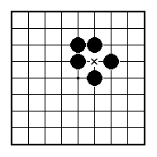
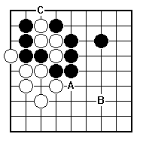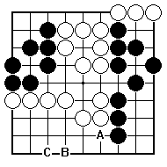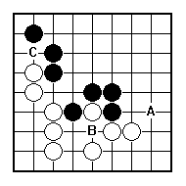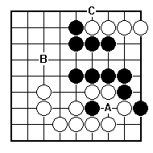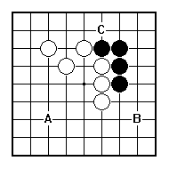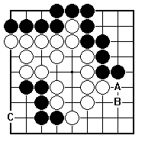
Should White play A, B or C?

Should Black play A, B or C?

Should Black play A, B or C?

Should Black play A, B or C?

Should Black play A, B or C?

Should Black play A, B or C?

NAME:
BRITISH GO ASSOCIATION CERTIFICATE LEVEL 3 - SHEET 9

BIG AND SMALL (PART 2)

